[](https://www.networkhomes.org.uk/)

**Sheltered Housing Referral Form**

**Instructions for Referral Agent**

**Applicants must:**

* Be over 60, or over 55 with a disability or support need
* Have no history of anti-social behaviour or current arrears

**Eligibility for social housing – applicants must:**

* Have a gross household income of less than £35,000 for a 1 bed flat, and less than £45,000 for a 2 bed flat, unless there is an extenuating need
* Be permanently living in the UK and not subject to immigration control (see the Asylum and Immigration Act 1996) unless deemed eligible by the Secretary of State (ousing Act 19HHousing Act 1996)

**Please check the applicant fits the criteria above, as well as their Local Authority’s social housing criteria. Please verify they have valid ID. All information will be treated as confidential. We will make two reasonable offers of housing before the applicant is removed from our waiting list.**

**FRAUD WARNING**

**Network Homes takes the act of fraud very seriously. Should you be found to be committing a fraudulent act at any stage of this offer, we will notify the police and the local authority’s Fraud Prevention Team.**

**Photographs**

Please attach a recently taken passport sized photograph of the main applicant and the joint applicant (if applicable)

**Main**

**Applicant**

**Photo**

**Joint**

**Applicant**

**Photo**

**Sheltered Housing Referral Form**

**Referral Agency Details**

**Name**      _________________

**Address**      __________________________________________________________

**Name of person making referral**      _________________ Da**te**      _______

**Contact Number**      ______________ **or, alternatively call**       ____________

**Email Address**      _____________________________

**Applicant Personal Details**

|  |  |  |
| --- | --- | --- |
|  | **Main Applicant** | **Joint Applicant** |
| **Title** |  |  |
| **First Name** |  |  |
| **Surname** |  |  |
| **Current Address**  Including post code |  |  |
| **Contact Number**  (Mobile Preferred) |  |  |
| **Date of Birth** |  |  |
| **Age** |  |  |
| **Gender** | Male  Female | Male  Female |

**Main Applicant**

**National Insurance number**      _________________

**Religion**      _________________

**Main spoken language**       _________________

**Please state any communication difficulties**

**Current Housing Situation**

**1. Your current housing situation (choose one only)**

Council tenant

Homeowner/occupier

Living in a Hotel or Hostel

Living with family

Living with friends

No fixed abode

Renting from a housing association

Renting from a private landlord

Other situation

**If other, please specify**       _________________

**2. Type of accommodation**

Bedsit/studio flat

Bungalow

Flat

House

Maisonette

Room in a house

**3. Is your accommodation permanent or temporary?**

Permanent  Temporary

**4. Is your accommodation in poor condition?** (Close to uninhabitable)

Yes  No

**5. Have you been served with a legal notice to leave?** Yes  No

**If yes, when does this notice expire?**      _________________

You must attach supporting documents as evidence

**6. Landlord’s details**

WE RESERVE THE RIGHT TO CONTACT YOUR LANDLORD IF NECESSARY

**Name**      _________________

**Address**      _________________________________________________________

**Contact number**      _________________

**7. If you are a homeowner/OCCUPIER is the property currently on the market or has it been sold subject to completion?**

You must attach supporting documents as evidence

Property is on the market to be sold  Property has been sold

(Subject to completion)

**Housing History**

**1.** Please complete the table to show all the addresses where you (the main applicant) have lived over the last **three years, starting with your most recent address**

|  |  |  |  |  |
| --- | --- | --- | --- | --- |
| **Date From** | **Date To** | **Full Address** | **Type of Property** | **Reason for leaving** |
|  |  |  |  |  |
|  |  |  |  |  |
|  |  |  |  |  |

**2. Have you ever been evicted from previous accommodation?**

Yes  No

**If yes, please give details**

|  |
| --- |
| **3. Please state your reason for leaving/wanting to leave your current accommodation** |

**Income, Employment and Assets**

**1. Are you employed?** Yes  No

**2. What is your weekly wage?** £      ­____

**3. Do you receive benefits?** Yes  No

**If yes, please give details in the table below**

|  |  |  |
| --- | --- | --- |
| **Name of Benefit** | **Weekly Amount** | **Length of Time in Receipt** |
|  | £ | Years Month(s) |
|  | £ | Years Month(s) |
|  | £ | Years Month(s) |
|  | £ | Years Month(s) |

**4. Do you have any savings or investments?** Yes  No

**Amount of total savings:** £      ­____

**Medical Support Needs**

**1. Do you have a medical condition, disability or mental illness?**

Yes  No

**If yes, please give a short description of your medical condition**

**2. Do you need any aids or adaptations to your accommodation?**

Please note any adaptations will be made after you have moved in and have done

an Occupational Health Assessment

Yes  No

**If yes, please give details**

**3. Do you need a ground floor flat or flat with access to a lift?**

Yes  No

**If yes, please give details**

**4. Do you use a mobility aid? (Wheelchair, Zimmer frame etc.)**

Yes  No

**If yes, please give details**

**5. Do you have support needs related to drug and/or alcohol abuse?**

Yes  No

**If yes, are you being supported with these needs?**

Yes  No

**Name and address of your support group or agency**

**Contact number of your support group or agency**      _________________

**Please give details of the support provided (type and frequency)**

**Next of Kin/Emergency Contact Information**

**Emergency Contact**  **Next of Kin**  **Name**      _________________

**Address**      ________________________________________________________________

**Telephone number** (mobile preferred)      _________________

**Relationship with Emergency Contact/Next of Kin**      _________________

**Consent and Authorisation**

All of the information provided within this referral form is accurate, and I agree Network Homes can contact me for further information.

**Main Applicant**

**Signed**      _________________________ **Date**      _________________

**Print name**      _____________________

**Referral Agent**

I have verified the applicant’s ID

ID type checked      _________________

I have checked the applicant(s)

* Are over 60, or over 55 with a disability or support need
* Have a household income of less than £35,000 for a 1 bed flat, and less than £45,000 for a 2 bed flat, unless there is an extenuating need
* Are permanently living in the UK and not subject to immigration control (see the Asylum and Immigration Act 1996) unless deemed eligible by the Secretary of State (ousing Act 19HHousing Act 1996)
* Have no history of anti-social behaviour or current arrears

**Signed**      _________________________ **Date**      _________________

**Print name**      _____________________

An incomplete referral form will not be processed, so please submit as much detail as you can and all relevant supporting documents. We will make two reasonable offers of housing before the applicant is removed from our waiting list. Please ensure that you use the **Enclosed Supporting Documents Checklist** and complete the **scheme preferences.**

**Enclosed Supporting Documents Checklist**

Please provide **copies** of one of each group of supporting documents to support your referral form

**Proof of identification**

Passport (Photo Page) Enclosed  N/A

Birth Certificate Enclosed  N/A

Freedom Pass Enclosed  N/A

**Proof of income**

Bank Statement (Within the last two months) Enclosed  N/A

Letter from the DWP (Most recent) Enclosed  N/A

Letter from the Pension Services (Most recent) Enclosed  N/A

**Supporting medical evidence**

Letter from your GP Enclosed  N/A

Letter from the hospital Enclosed  N/A

**Confirmation of housing situation**

Tenancy Agreement Enclosed  N/A

Notice of eviction/Notice of seeking possession Enclosed  N/A

Confirmation of sale of property (Solicitors letter) Enclosed  N/A

**Supporting Statement**

From a support worker, relative, landlord etc Enclosed  N/A

Please return this completed referral form, the Scheme Splash sheet, and all of the enclosed supporting documents to:

**Network Homes - Sheltered Voids and Lettings**

**8 Fulton Road**

**Wembley**

**Middlesex**

**HA9 0NU**

If have any questions about the referral form, please call [**020 8782 5477**](tel:02087825477)

**Accommodation Preferences**

**Would you consider self contained studio accommodation?**

This is a compact flat with one main room, a kitchen and a bathroom.

Yes  No

**Please tick all the schemes you would like to live in**

If you choose a limited number of schemes, you may have to wait longer for a flat

**Willesden (Brent)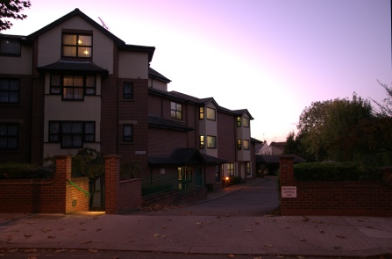Clovelly Court**

54 Blenheim Gardens.

NW2 4NQ

Phone: 020 8830 5088

1 beds ¦¦ one 2 bed only

**Willesden (Brent)**



**Beldanes Lodge**

23 Hawthorn Road,

NW10 2LR

Phone: 020 8451 6483

1 beds only

**Willesden (Brent)**



**Pavitt Court**

Hawthorn Road,

NW10 2LU

Phone: 020 8451 6483

1 beds only

**Kilburn (Brent)**

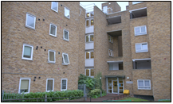**Morland House**

17 Brondesbury Road,

NW6 6QL

Phone: 020 7625 1814

Studios ¦¦ 1 beds

**Kingsbury (Brent)**



**Maple Lodge**

Birchen Grove, London,

NW9 8SE

Phone: 020 8200 6063

1 beds only

**Westminster (W9)**

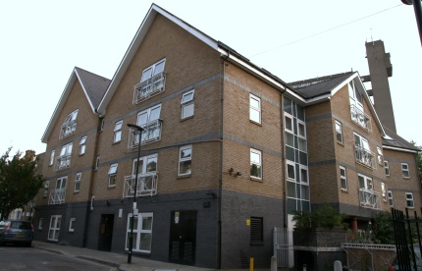

**Waterside Court**

75 Fermoy Road, W9 3NE

Phone: 020 8960 9727

1 beds ¦¦ 2 beds

**Stonebridge (Brent)**

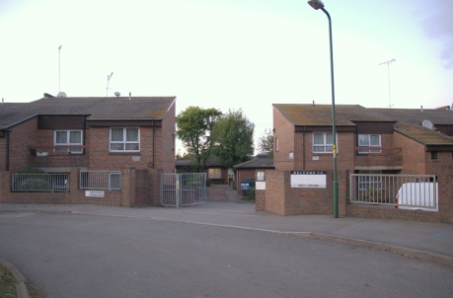**Biko House**

2 Barry Road, London,

NW10 8DW

Phone: 020 8965 8575

Studios ¦¦ 1 beds

**Stonebridge (Brent)**

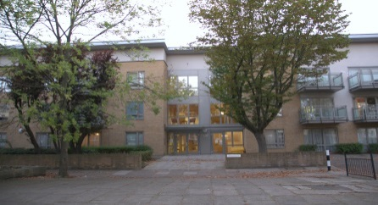**Newcroft House**

Stonebridge Park,

NW10 8EB

Phone: 020 8965 2199

1 beds ¦¦ 2 beds

**Wembley (Brent)**

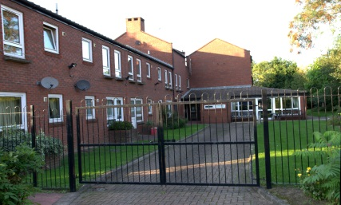**Corsham House**

Victoria Court, Wembley

HA9 6QN

Phone: 020 8903 7052

Studios only

**Wembley (Brent)**

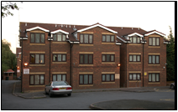

**Rydal Court**

44 Oxenpark Avenue,

Wembley. HA9 9TA

Phone: 020 8908 6595

1 beds only

**Kingsbury (Brent)**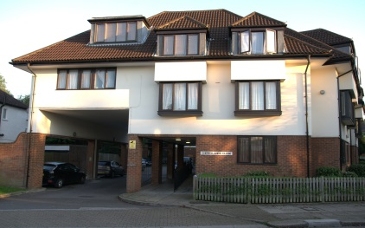

**Cherrylands Close**

Deanscroft Avenue,

NW9 8EW

Phone: 020 8200 5228

1 beds only

**Neasden (Brent)**

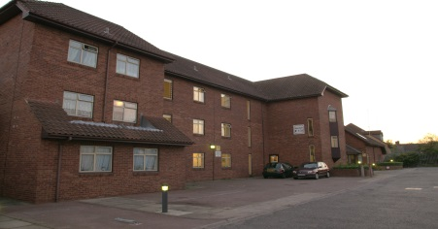**Arran Court**

Press Road, London

NW10 0EE

Phone: 020 8452 0385

1 beds ¦¦ one 2 bed only

**Neasden (Brent)**

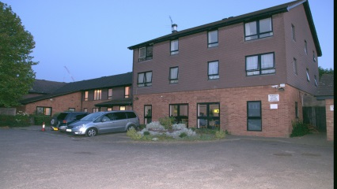**Roberts Court**

19 Neasden Lane,

NW10 2RS

Phone: 020 8451 5440

1 beds only

**Wembley (Brent)**

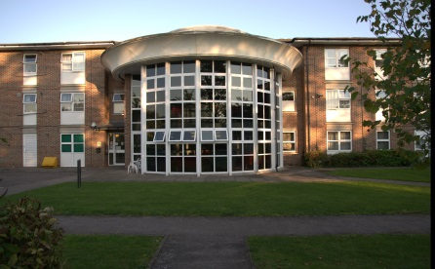

**Elsley Court**

Babington Rise, Wembley

HA9 6SN

Phone: 020 8902 2489

1 beds only

**Westminster (W9)**

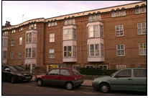

**Mary Seacole House**

29 - 39 Warlock Road,

W9 3LP

Phone: 020 8968 4223

1 beds ¦¦ one 2 bed only

**Harrow (Harrow Weald)**

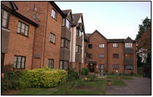**Parkfield House**

Headstone Lane, Harrow,

HA2 6NQ

Phone: 020 8420 1304

1 beds ¦¦ 2 beds

**Haringey (Tottenham)**

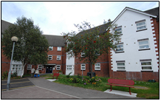

**Portland Place**

59-153 Portland Road,

London, N15 4SY

Phone: 020 8800 8694

1 beds ¦¦ 2 beds

**Haringey (Tottenham)**

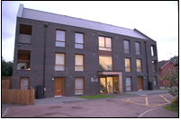

**Demacque Court**

45 Portland Road, London,

N15 4SY

Phone: 020 8800 8694

one 1 bed flat ¦¦ 2 beds

**Barnet (Edgware)**

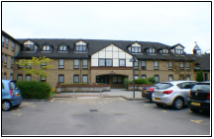**Kingsley Court**

Tayside Drive, Edgware,

HA8 8RE

Phone: 020 8905 4802

1 beds ¦¦ 2 beds

**Brondesbury (Brent)**

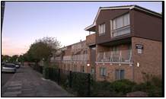**Avonhurst House**

Coverdale Road, London,

NW2 4DF

Phone: 020 8451 6383

Studios ¦¦ 1 beds

**Brondesbury (Brent)**

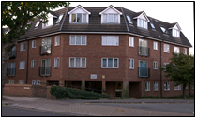**Knightleas Court**

111 Brondesbury Park,

London, NW2 5JQ

Phone: 020 8451 4891

1 beds ¦¦ 2 beds ¦¦ Studios

**Kensal Green (Brent)**

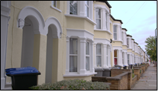**Purves Road**

London, NW10 5SU

Phone: 020 8960 7418

1 beds only